

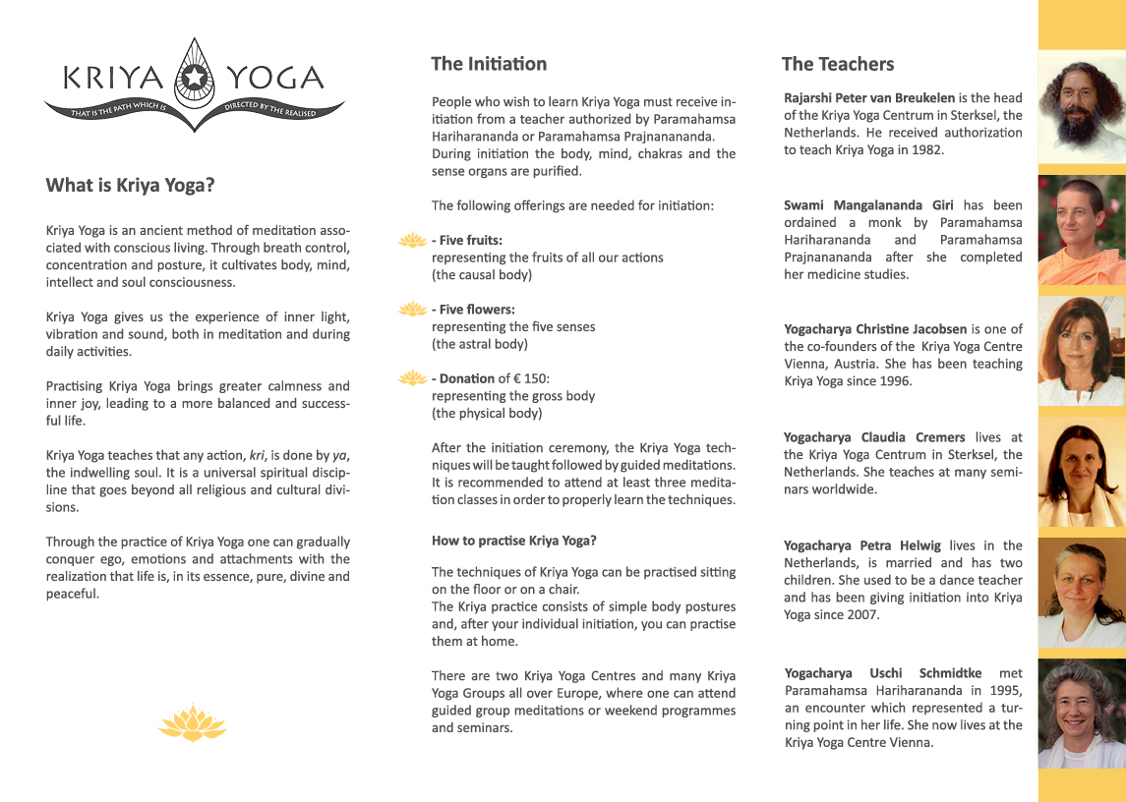

**Saturday, 6th July 2019**

08:45 Preparation for Initiation

09:00 Initiation followed by Meditation

13:00 Light Vegetarian Lunch available - €5

16:00 Explanation of Techniques

17:00 Meditation

**Sunday, 7th July 2019**

09:00 I Kriya Guided Meditation

11:00 Questions & Answers followed by

Guided Meditation

13:00 Light Vegetarian Lunch available - €5

14:00 Guided Meditation

15:30 End of Seminar

*** Only those initiated into the Kriya Yoga lineage of Paramahamsa Hariharananda and Paramahamsa Prajnanananda are allowed to participate at the Meditation and Techniques classes. ***

**Seminar in Tallow,Co.Waterford**

**6-7th - July 2019**

**with Swami Mangalananda Giri**

**Costs** (not for new initiates)

The Seminars in Waterford are funded by donations/contributions and are organised by volunteers.

Sat and Sun € 30 (insert price) per day

€ 15 (insert price) for half day

**Information**

An optional warmorganicvegetarian meal will be provided for a cover cost of €5/person for all participants.

Please bring a blanket/yoga mat, a cushion and socks with you. We also recommend loose and comfortable clothing.

Kindly arrive 30 minutes before initiations start and 15 minutes before each meditation class.

Remember also to switch off your mobile during the program.

**Information and Registration**

Kriya Yoga Group (Cork/Waterford)  
Mobile: 00353/(0)89 2536880  
Email: kriyaireland1@gmail.com

**Venue Rectory Cottage**

**West Street**

**Tallow, Co. Waterford.**

(Kriyayogaireland.org)